**HANDS ON ASSIGNMENT - POWER BI**

**Connecting to the SQL Server**

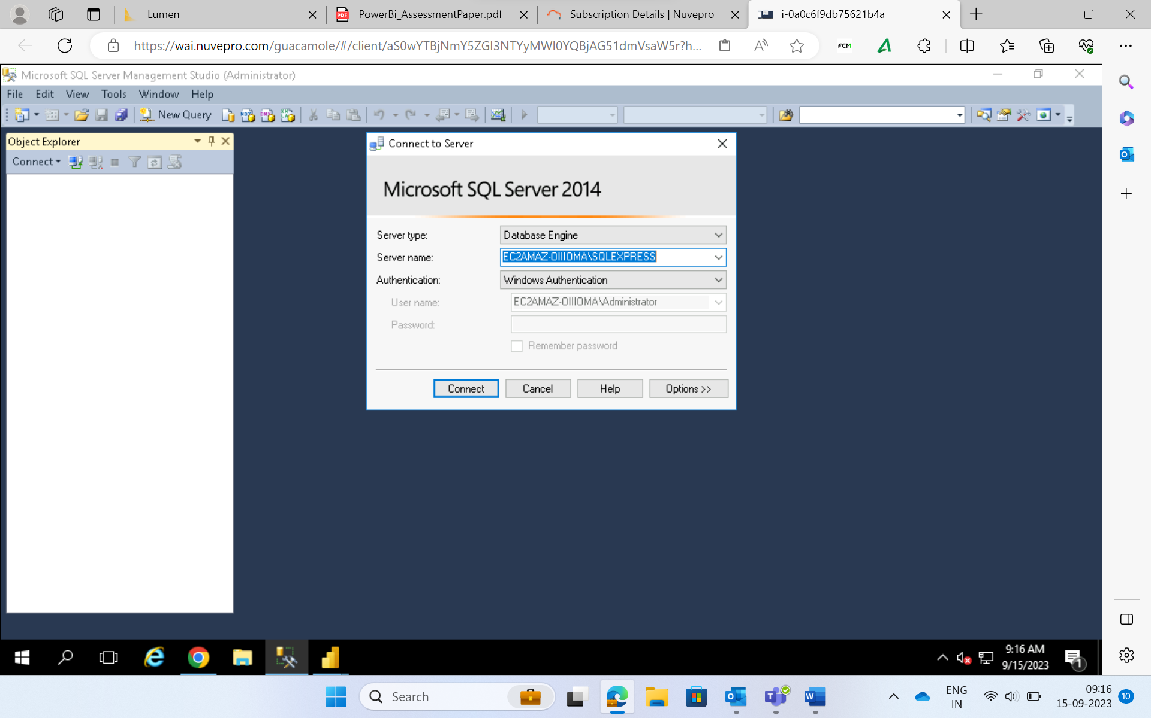

**Creation Of Database And Tables**

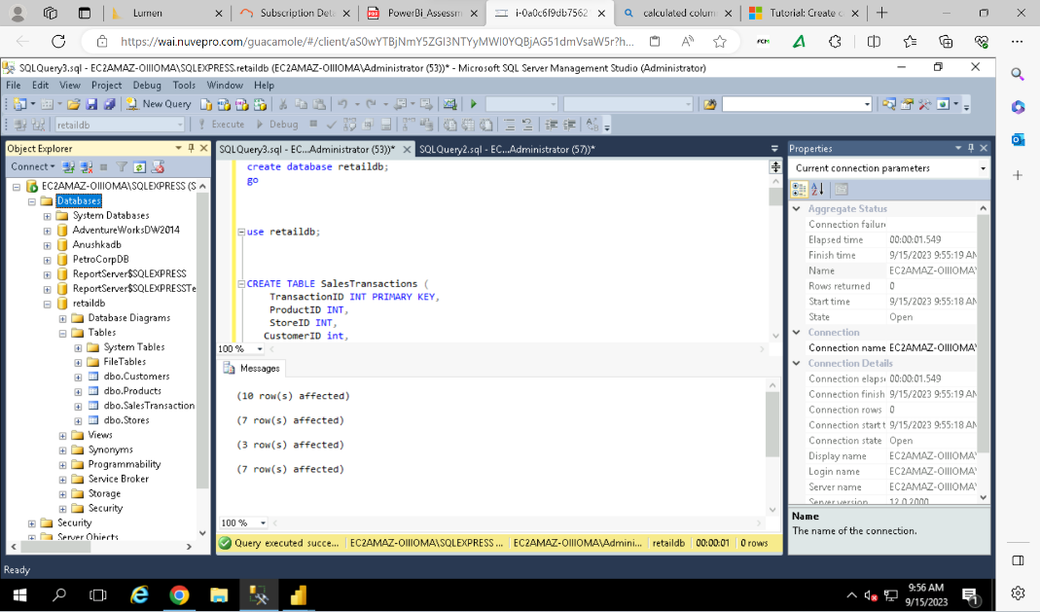

**Connecting to SQL Sever On Power BI**

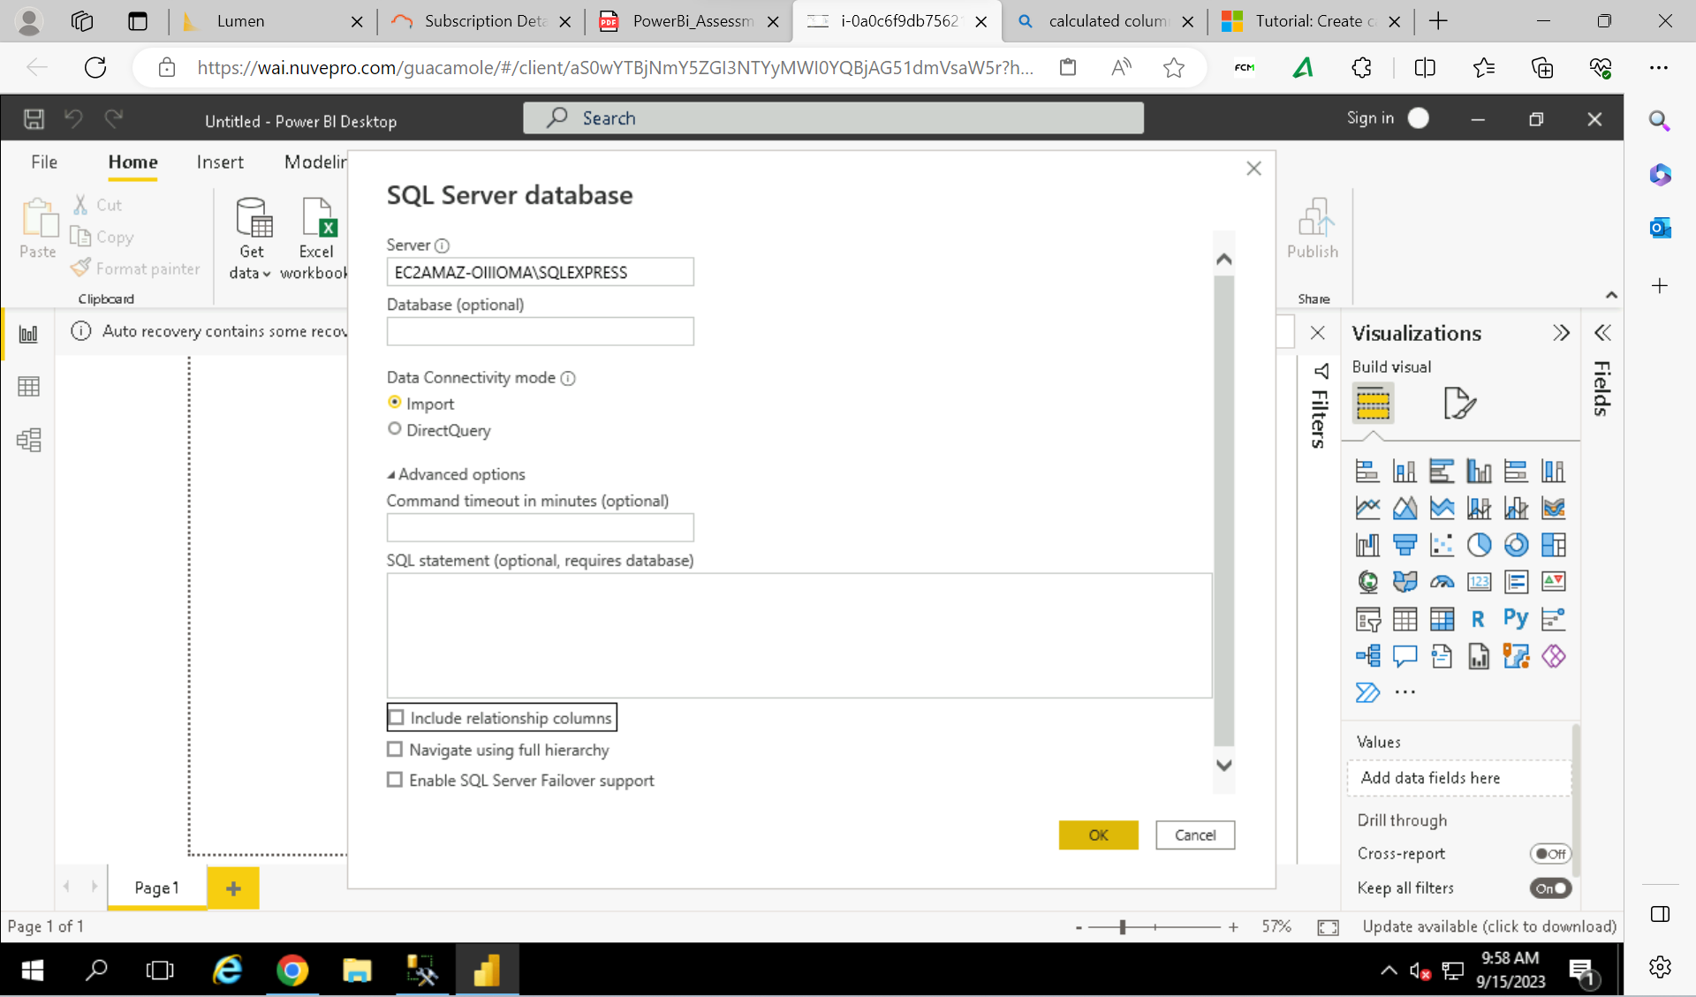

**Loading The Tables Into Power BI**

**Managing & Creating The Table Relationships**

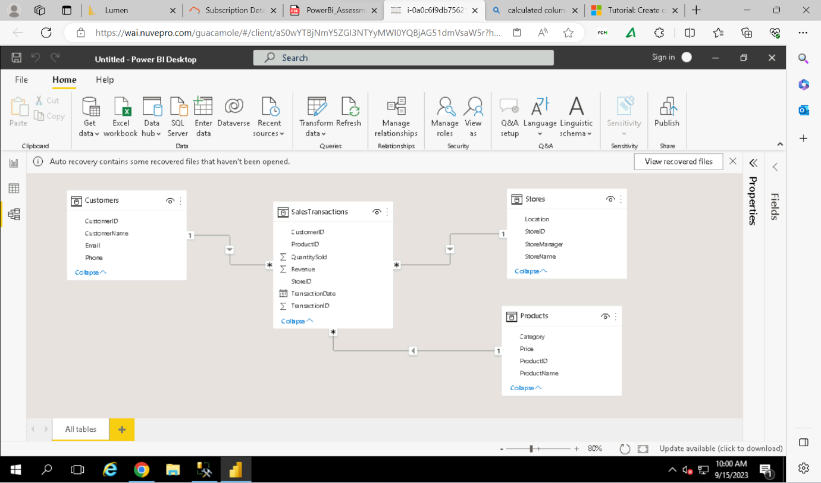

**Creating The Hierarchy**

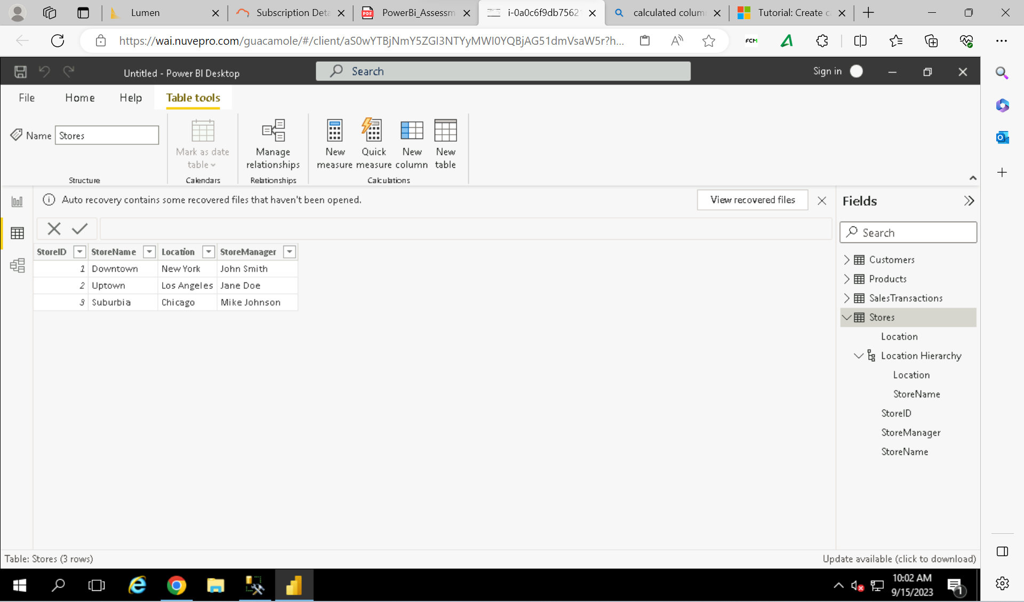

**Merging The Tables**

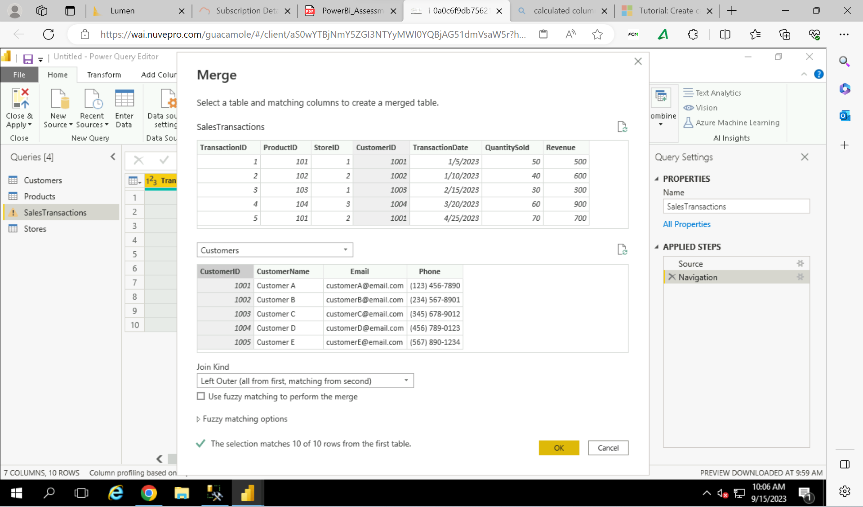

**Clean The Data**

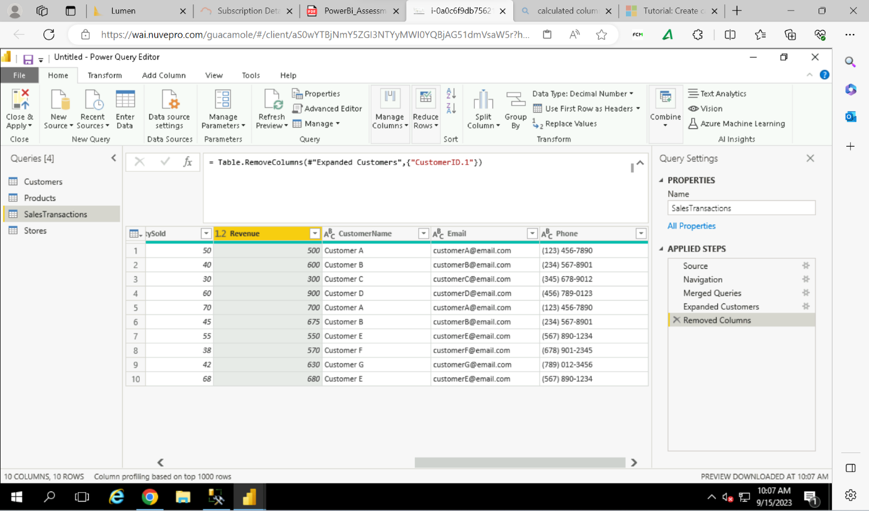

**Addition Of Columns**

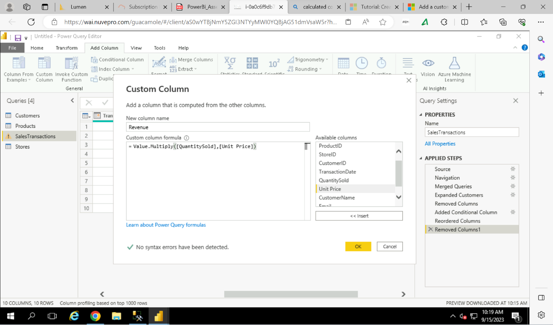

**Who are the top-spending customers based on their total purchase amount?**

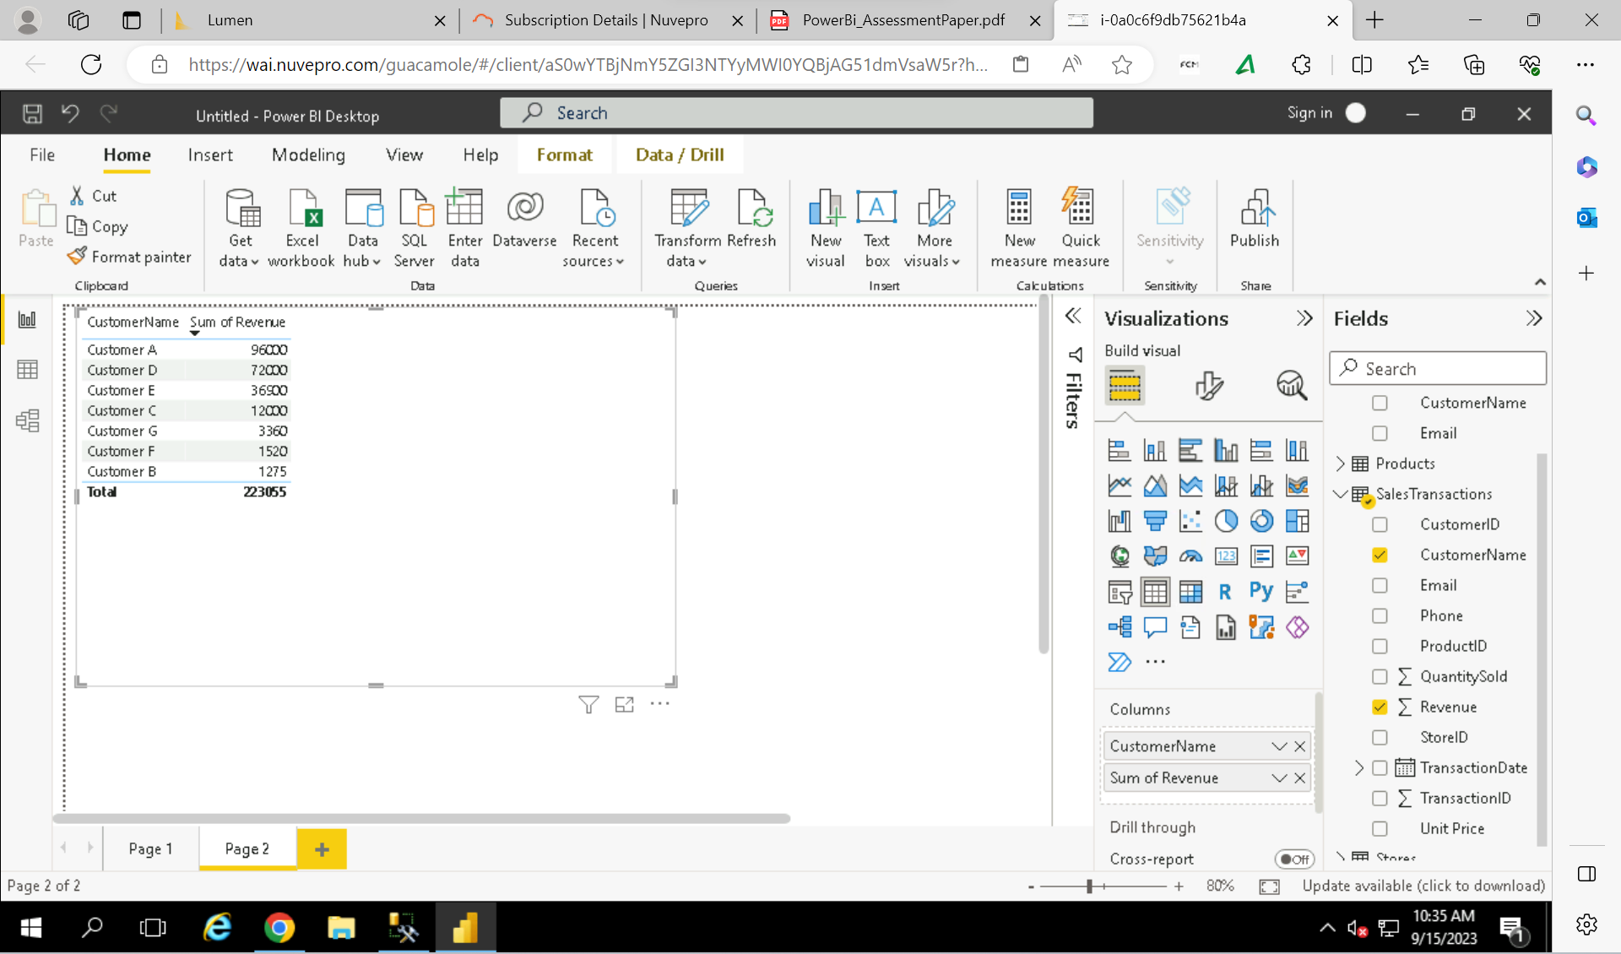

**How is sales revenue distributed among different store managers?**

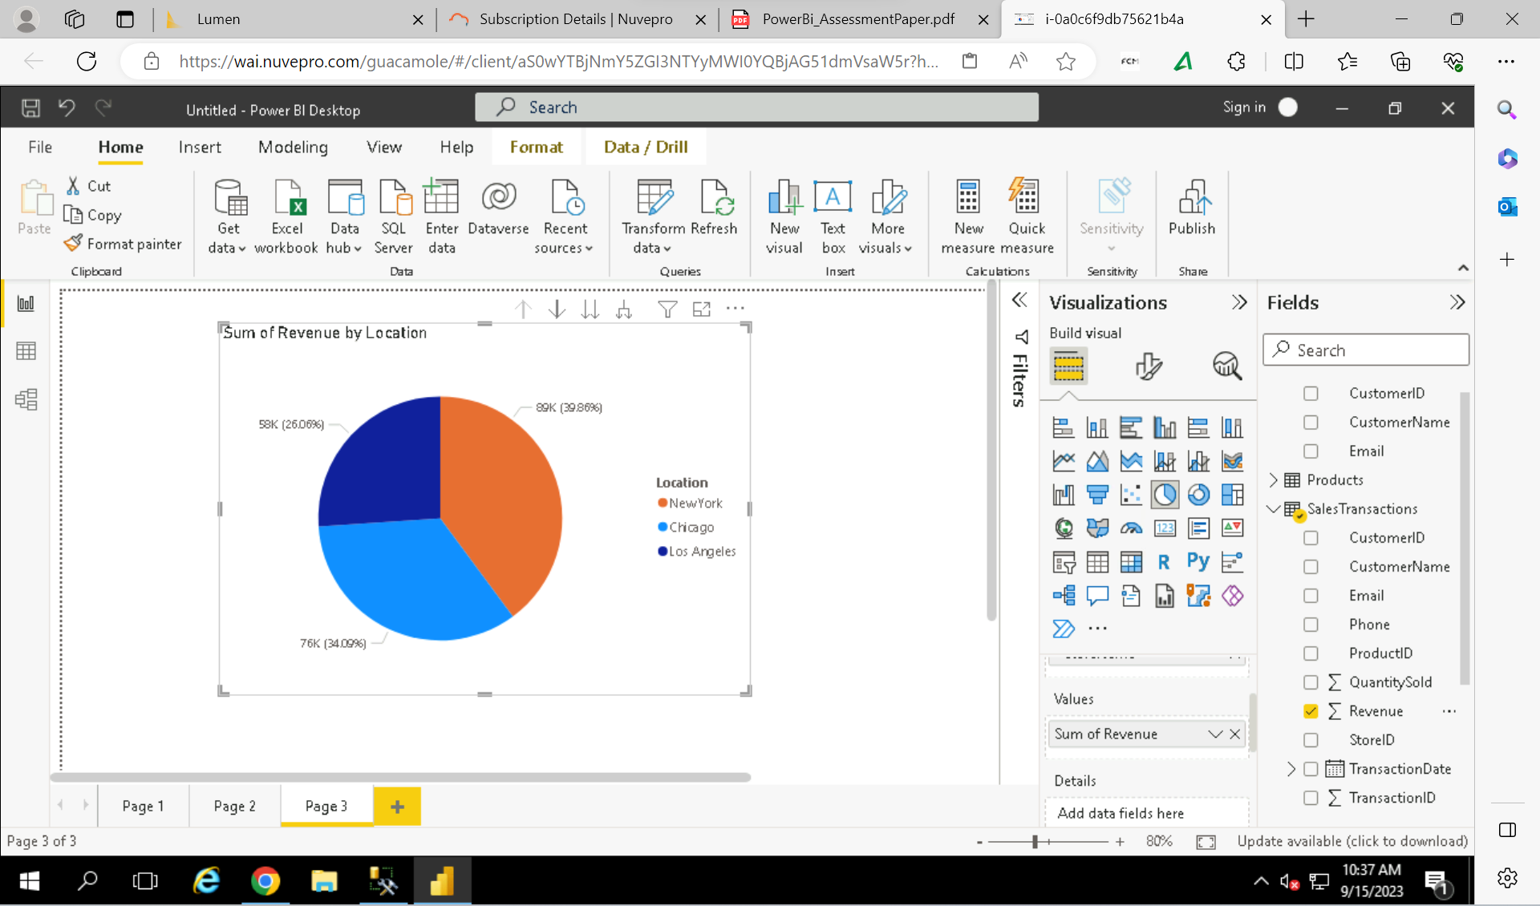

**What is the average price of products in each category?**

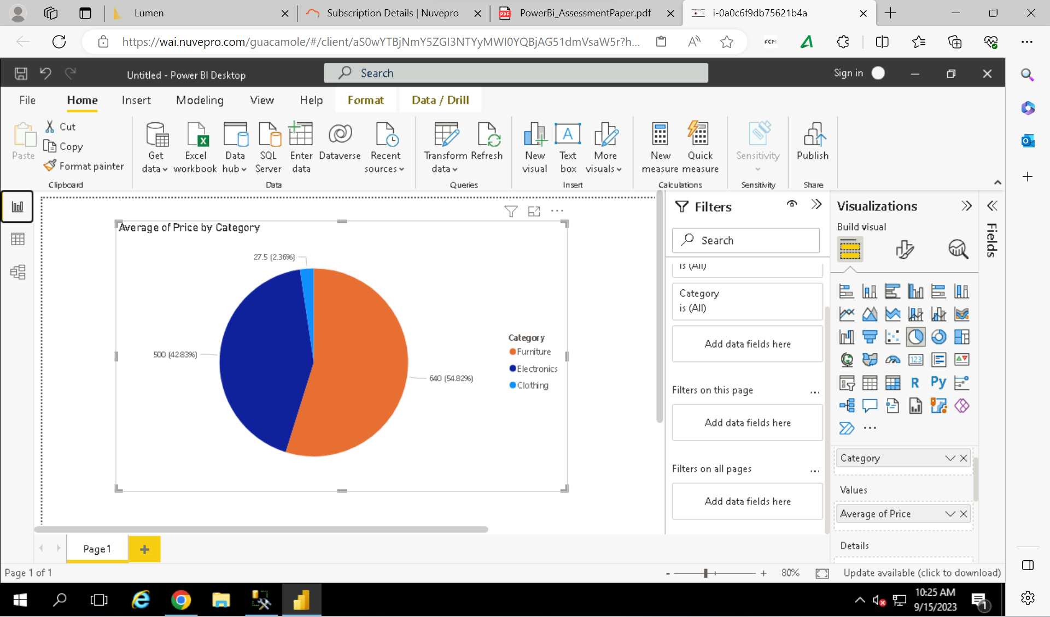

**Are there specific days of the week when sales are higher?**

**How do sales trends vary by product category on a monthly basis?**

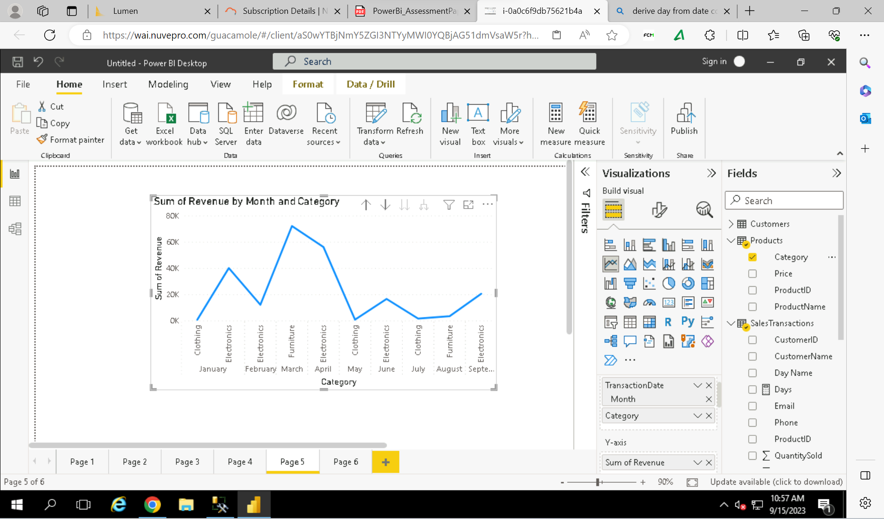

**What percentage of products account for 80% of total sales revenue?**

**Are there any trends in repeat customer purchases?**

**Which product categories perform best at each store location?**

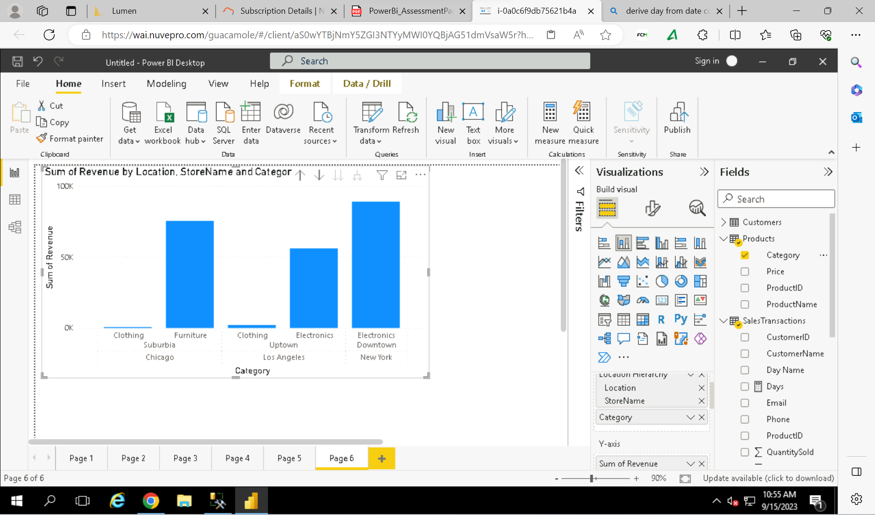

**Are there any seasonal patterns or trends in sales for specific products or categories?**

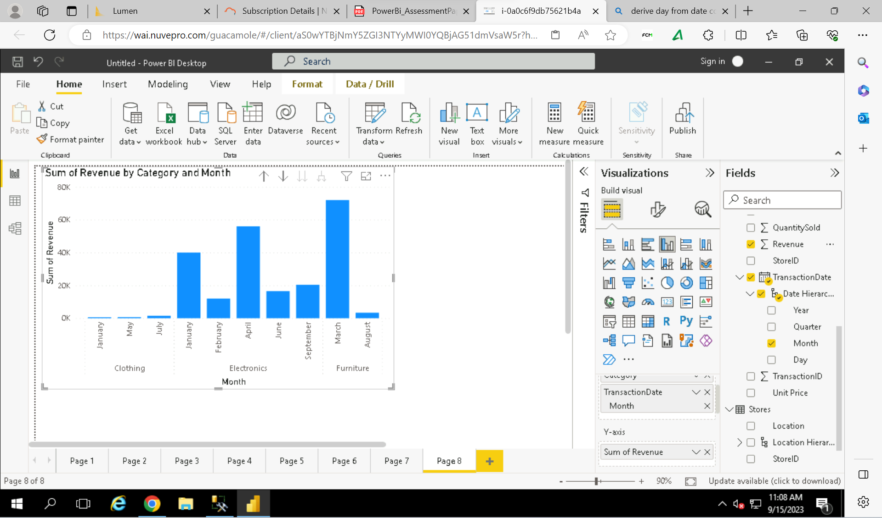

**Can customers be segmented into high, medium, and low-value segments based on their purchase history.**

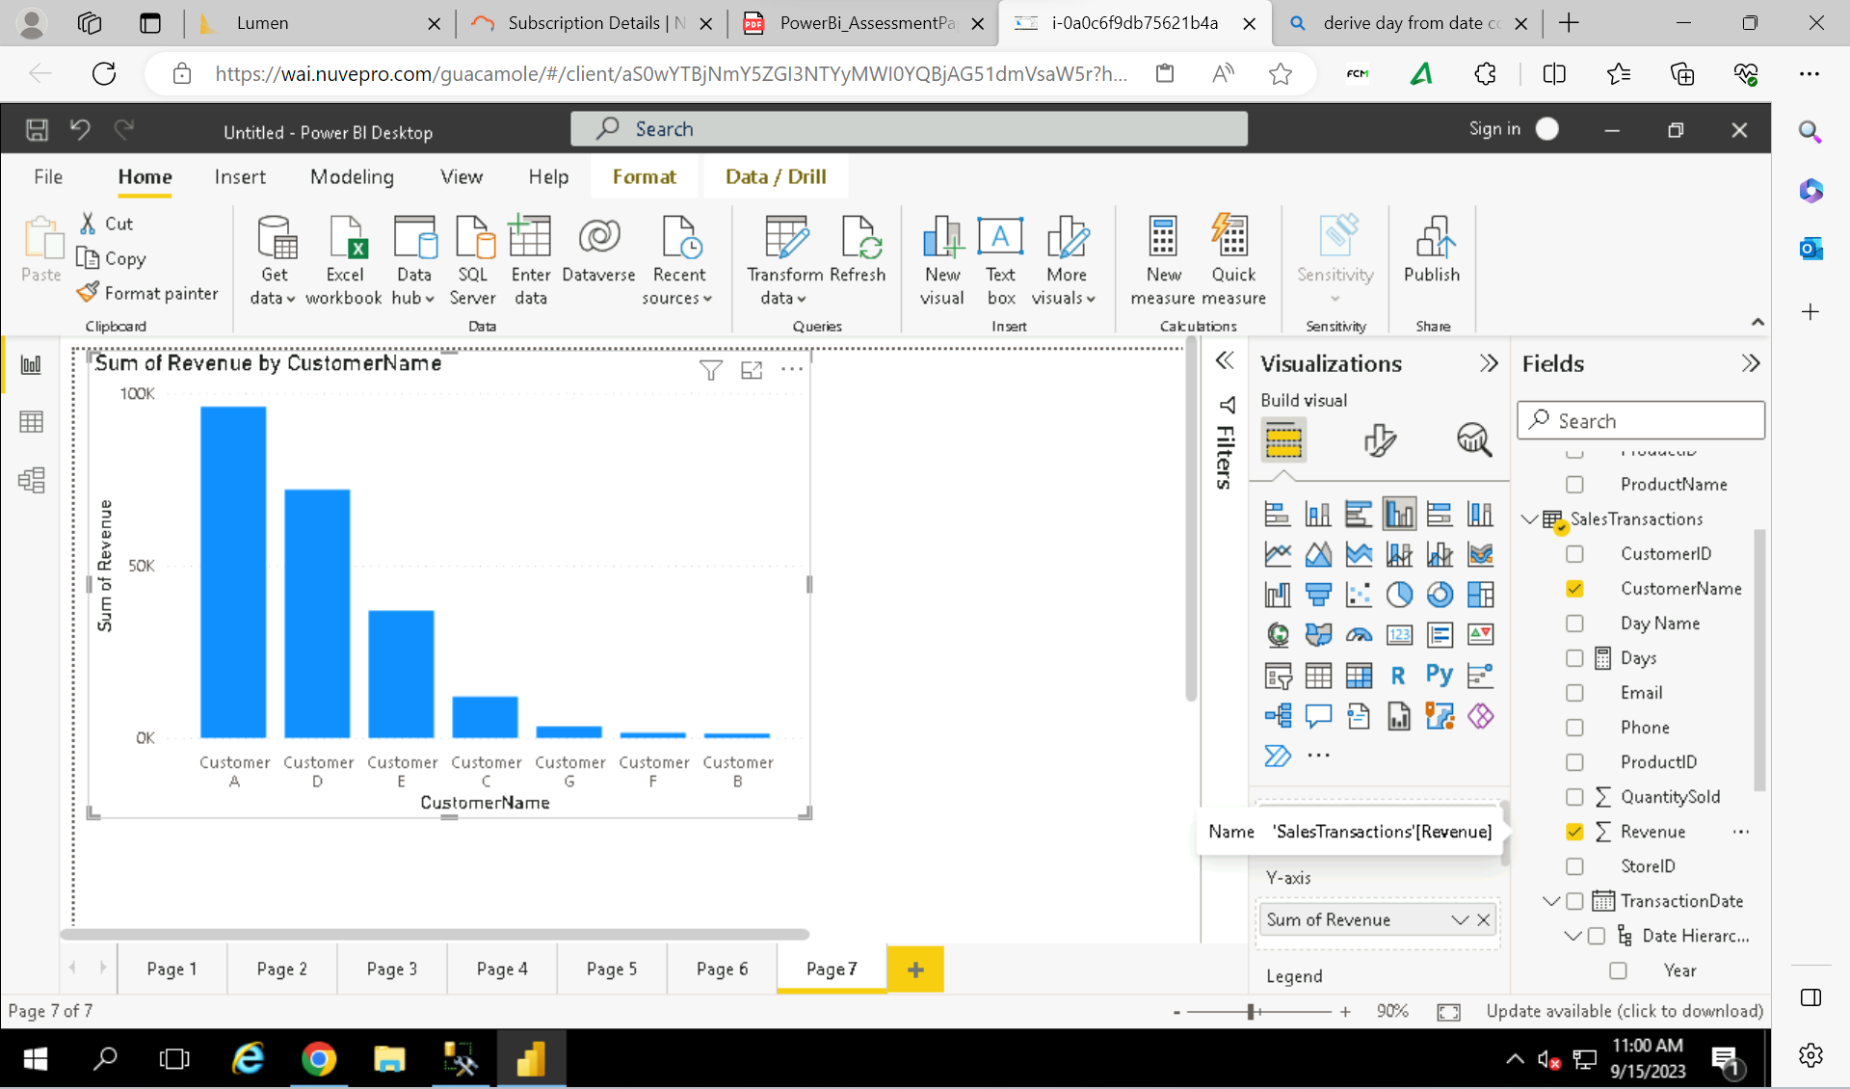

Customer A, Customer D: High Segmented

Customer E, Customer C: Medium Segmented

Customer G, Customer F, Customer B: Low Segmented